Step 1: Sign in to Azure Portal
- Open your browser.
- Go to Microsoft Azure Portal.
- Login using your Azure account.

Step 2: Create a Logic App
- In the Search bar, type Logic Apps.
- Click Logic Apps service.
- Click + Create.
Fill the required details:
- Subscription: Azure for Students
- Resource Group: Create new (Example: logicapptask)
- Logic App Name: EmailAutomationApp
- Region: East Asia / nearest region
- Plan Type: Consumption
- Click Review + Create.
- Click Create.
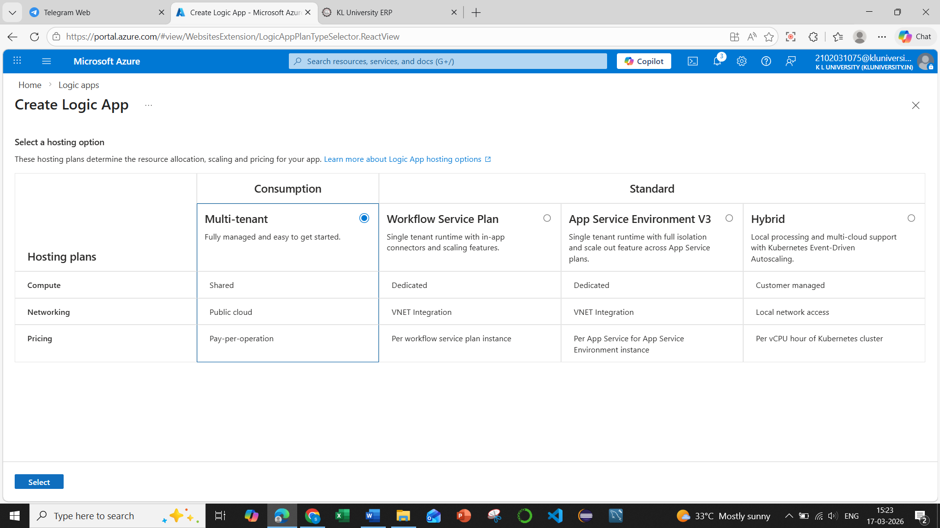
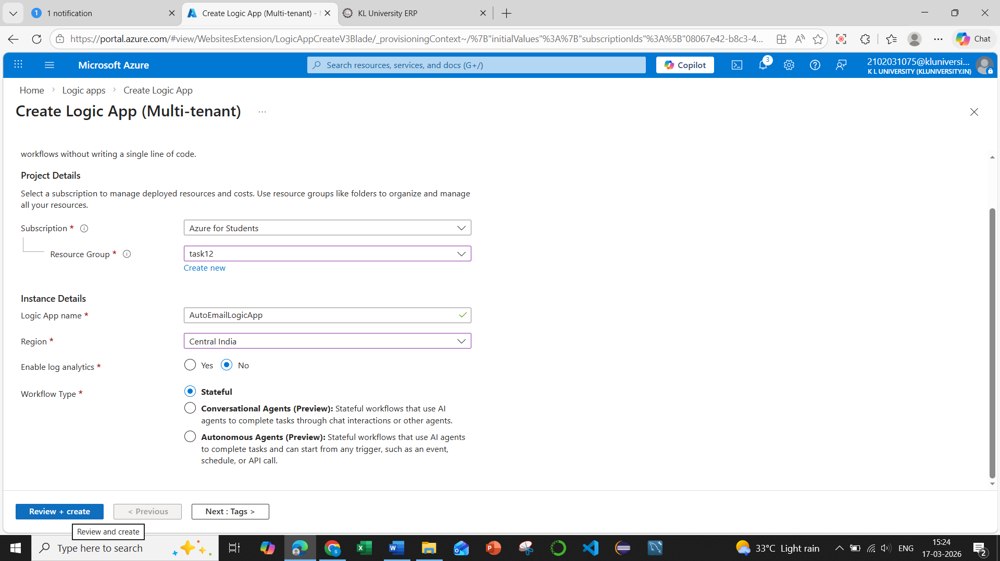
Click on review+ create
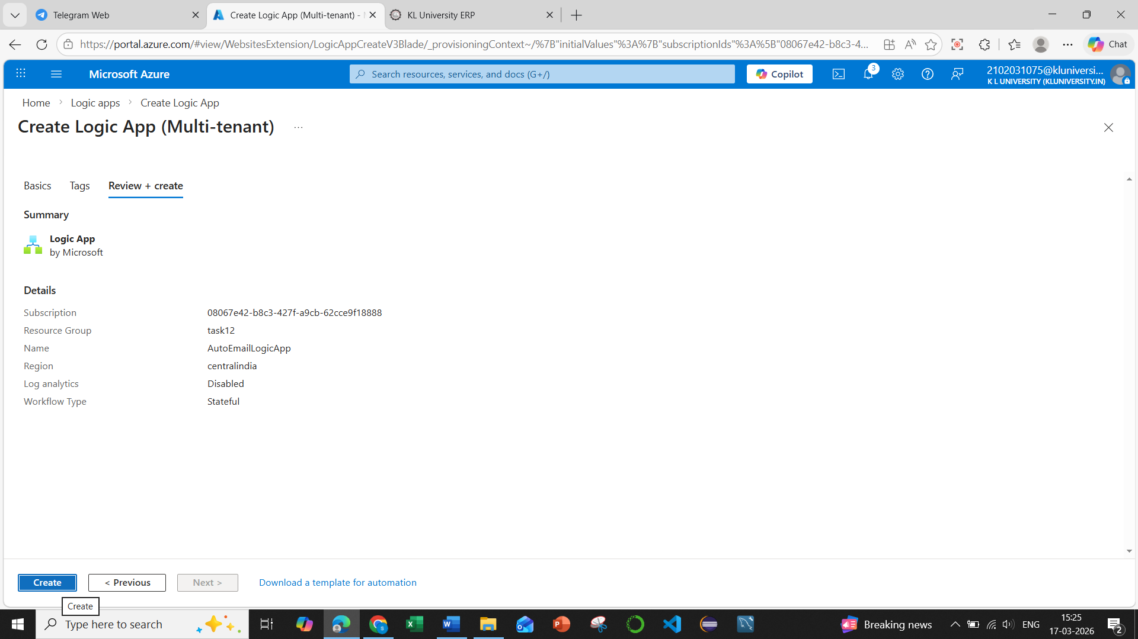
Click on create
Wait for the deployment to complete.
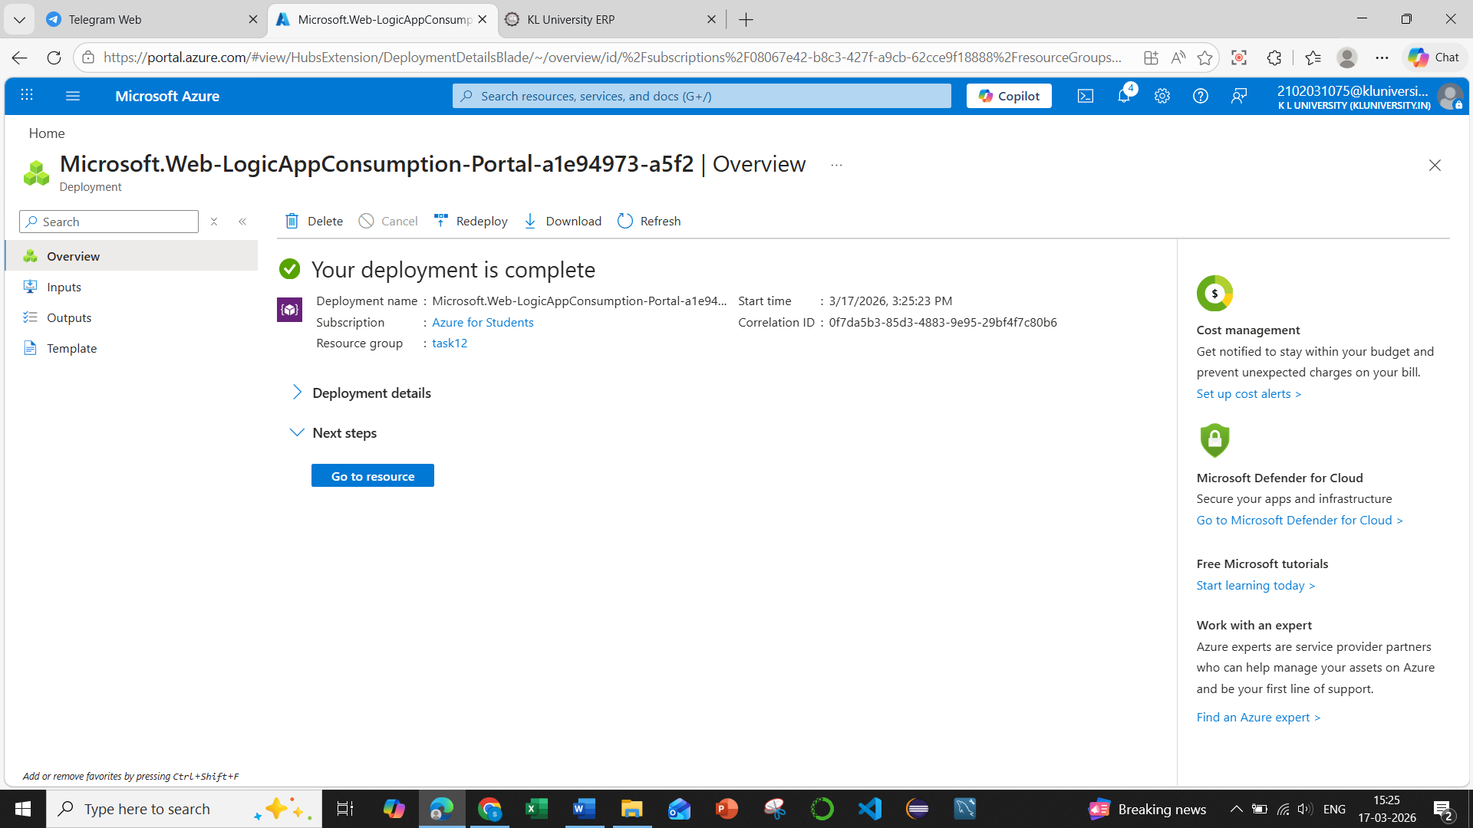

Step 3: Open the Logic App Designer
- Click Go to Resource.
- In the left panel, click Logic App Designer.
- Choose Blank Logic App template.
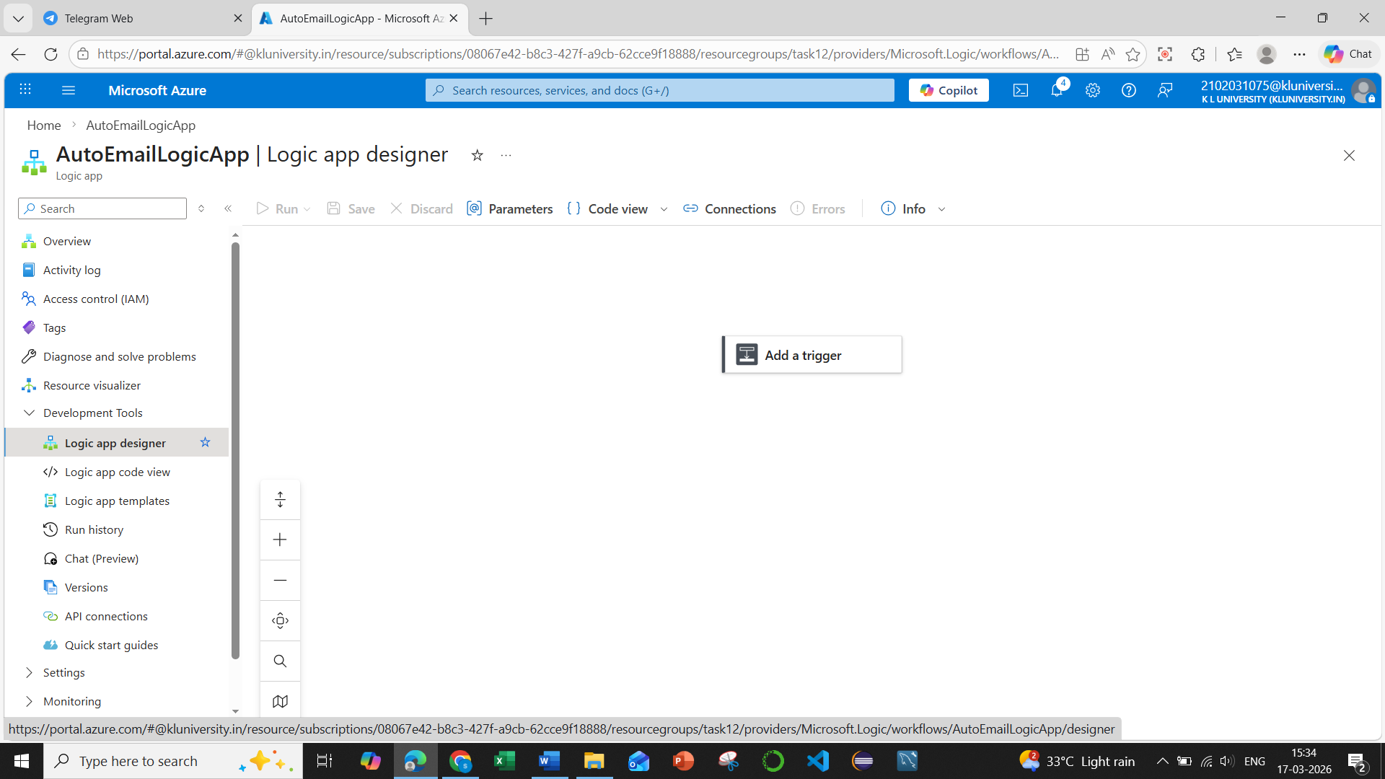

Step 4: Add a Trigger
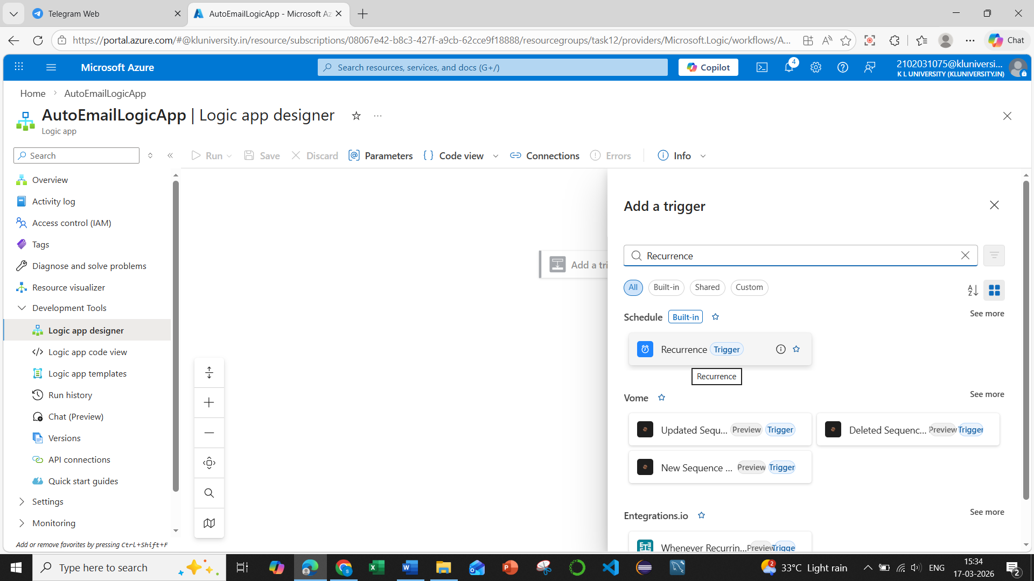
A trigger starts the workflow.
Example trigger: Recurrence (automatic schedule)
- Search Recurrence.
- Select Recurrence Trigger.
- Set the schedule:
  - Interval: 1
  - Frequency: Day / Hour / Minute
This means the Logic App runs automatically at the chosen interval.
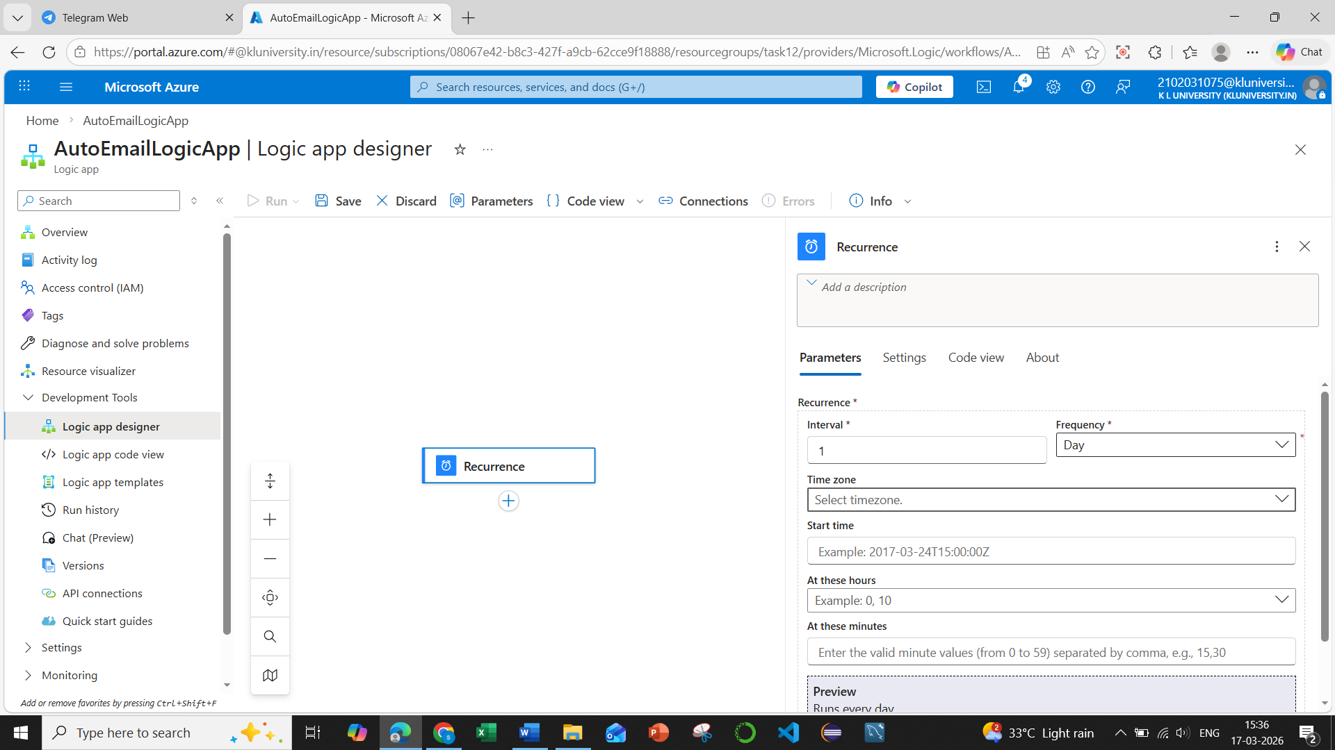

Step 5: Add an Email Action

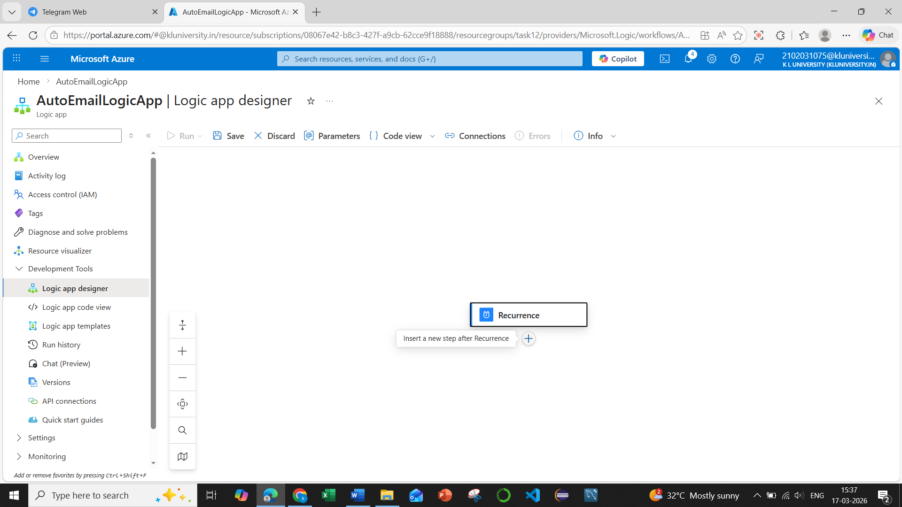
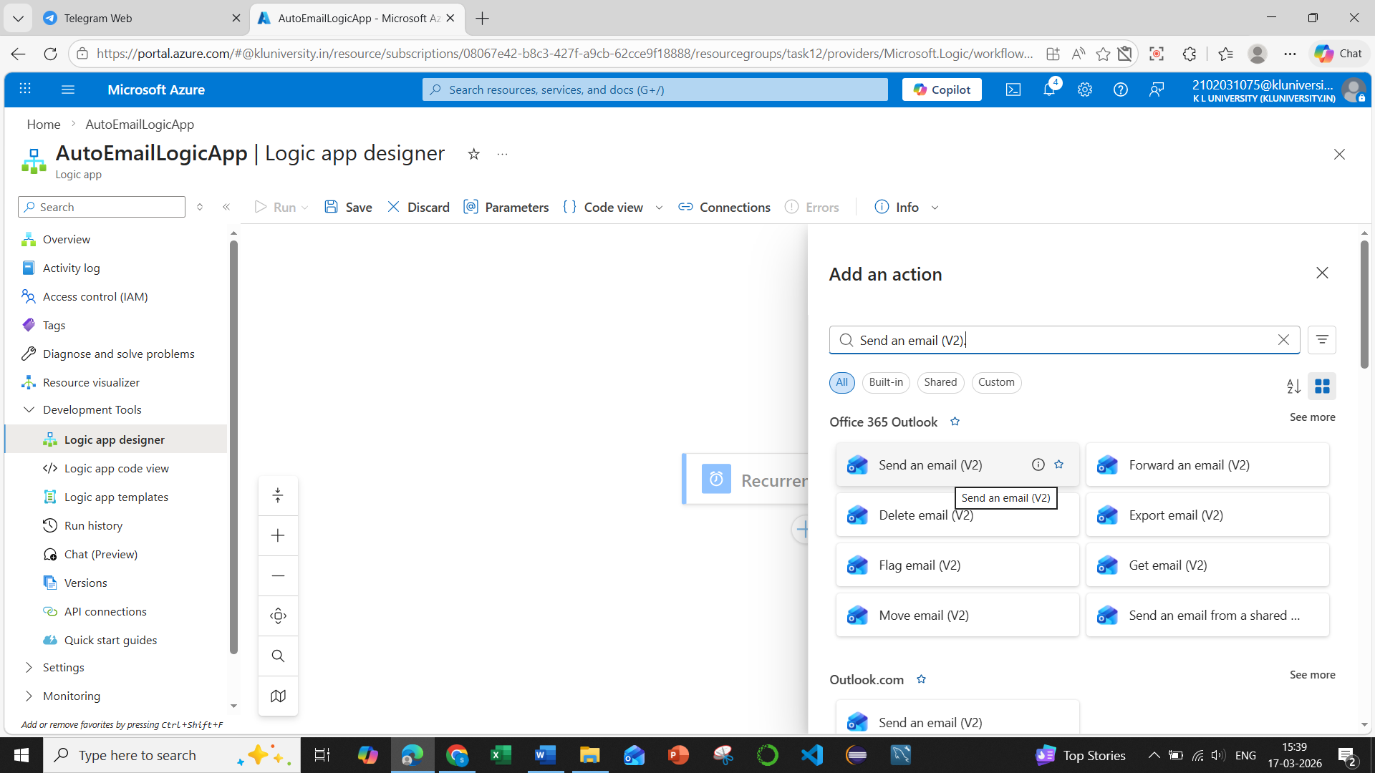
Now configure the automated email.
- Click + New Step.
- Search Send an email (V2).
- Choose Office 365 Outlook or Gmail connector.
- Sign in to your email account when prompted.
Fill the email details:
- To: Receiver email address
- Subject: Example – Automated Notification from Azure Logic App
- Body: Example – This email was automatically sent using Azure Logic App.
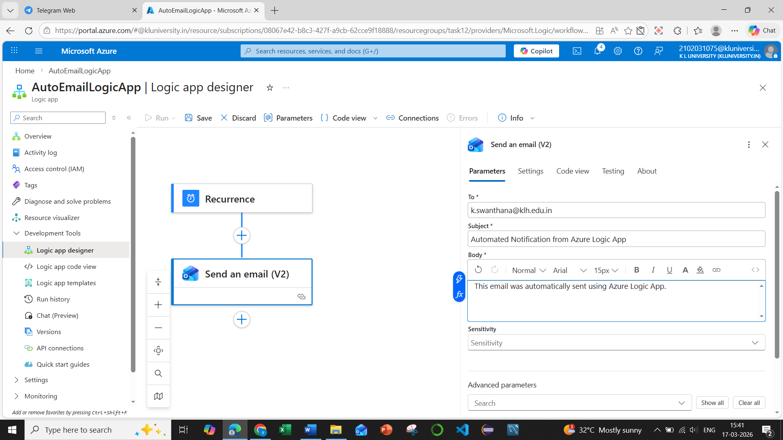

Step 6: Save the Logic App
- Click Save at the top.
- The workflow is now active.
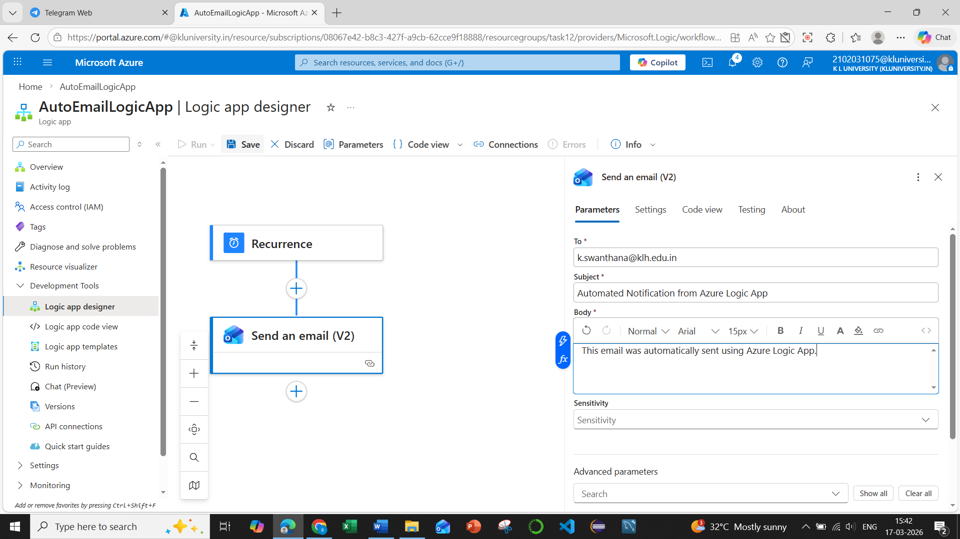

Step 7: Test the Logic App
- Click Run Trigger or wait for the scheduled time.
- Check your email inbox.
- You should receive the automated email.
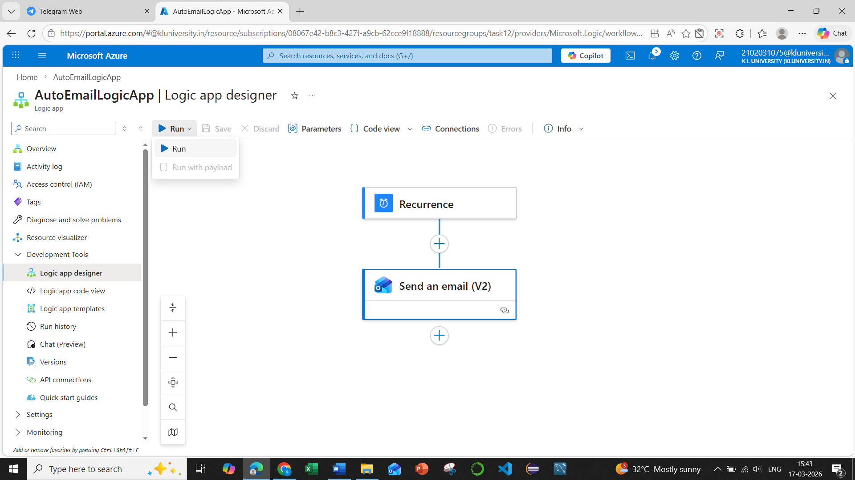
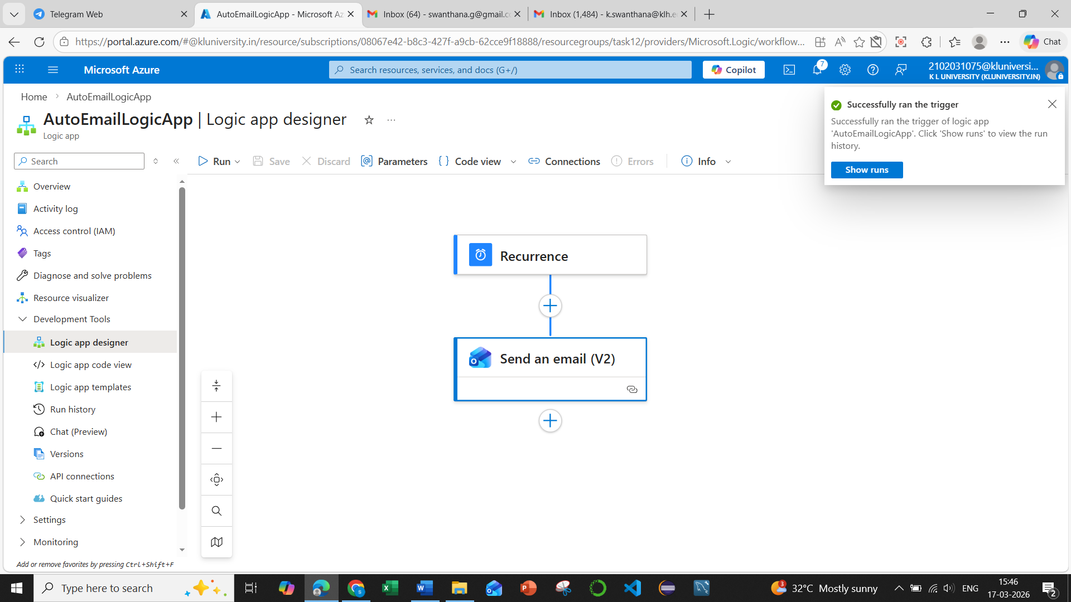
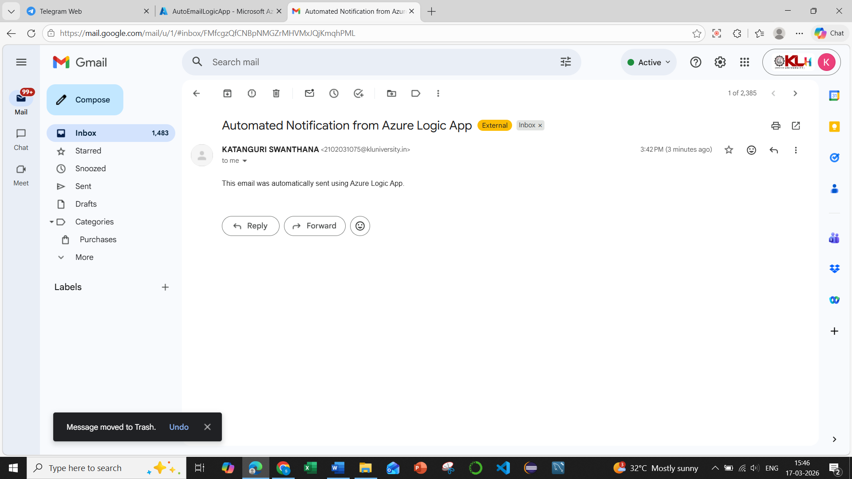
✅ Workflow Structure
Trigger (Recurrence)
↓
Action (Send Email)
↓
Automated Email Sent

